SETUPS
Agency Setup

Top Section: Administrative
Side Button: Settings

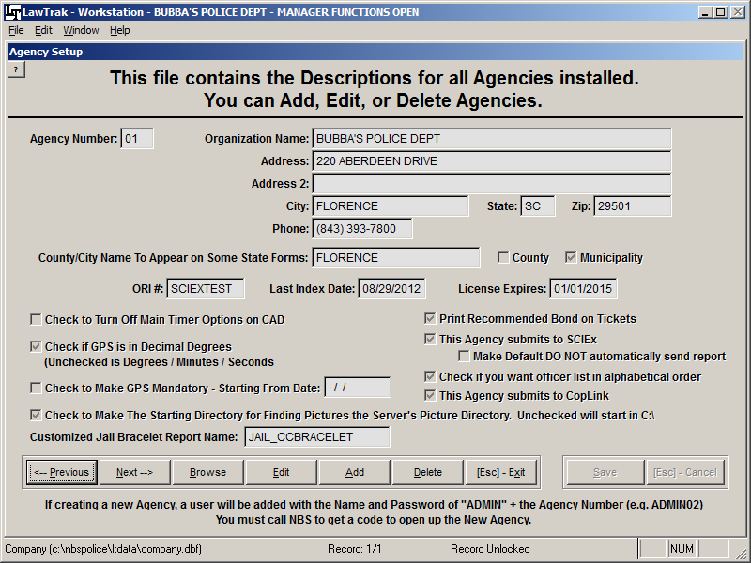

This file contains information about your agency that will appear on many reports and exports. Edit this screen to reflect your Agency Information. There are also “switches” which determine how some data is handled.

LawTrak can accommodate Multiple Agencies using the same data files. If you plan to have multiple agencies in the same LawTrak database, please call LawTrak Support to set this up.

Following is a list of “switches” on the Agency Setup page:

Check if GPS is in Decimal Degrees – Unchecked is Degrees / Minutes / Seconds: This switch shows how the Latitude/Longitude is initially displayed on several input screens. This switch affects the entire agency. However, there is usually a switch beside the GPS coordinates to toggle back and forth between the two choices if necessary.

Check to Make GPS Mandatory – Starting From Date: This will make collecting GPS information on Incidents and Tickets mandatory. The officer will not be able to save the records unless there is a GPS reading. This should only be used by agencies that have mapping programs which allow you to select places on a map, or you have hand-held GPS displays. Any record which happened before the starting date can be saved without GPS coordinates.

Check to Make The Starting Directory for Finding Pictures the Server’s Picture Directory. Unchecked will start in C:\: When using the Get Picture option for Mug Shots, Collision Report Drawings, Additional Pictures, etc., you can select to start looking for the pictures in either the Main LawTrak Picture Directory or C:\. The advantage to starting in the C:\ directory is that there is less of a chance to accidentally delete pictures on the server. Since most pictures come from folders residing on the local computer or digital cameras, you usually have to navigate away from the Main Picture Directory anyway.

Print Recommended Bond on Tickets: This will cause the Recommended Bond to be printed on the Drivers Copy of the E-Ticket if it is filled in.

This Agency Submits to SCIEx: If the agency sends records to SCIEx, this switch causes Incident Reports and Outstanding Warrants to be sent to SLED automatically. The switch for Make Default DO NOT automatically send report will put an Incident Report on hold until it has been reviewed before it is sent to SCIEx.

This Agency Submits to CopLink: If the agency sends records to CopLink, this switch causes several types of records to be created so that they can later be uploaded to the CopLink server.

Check if you want officer list in alphabetical order: On several data entry screens, you can press F1 to get an officer listing. Checking this switch will put the officers in Alphabetical Order. If it is not checked, the officers will be listed in Officer ID order.

Customized Jail Bracelet Report Name: If your agency uses a Jail Bracelet other than the normal default one, enter the name here. This report must be created by LawTrak Support.

Court / Additional Agency Settings

Top Section: Administrative
Side Button: Settings

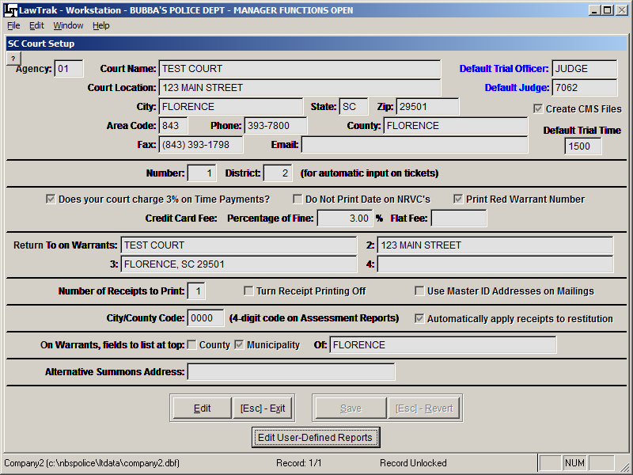

This screen contains information about the local court that will be used on reports and mail merge letters. There are also some “switches” to turn on and off, and some fields that will fill in certain data entry screens automatically.
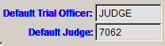
The Default Trial Officer and Judge will automatically fill in the Trial Officer and Judge fields on Tickets and Warrants. These should be set to the Judge who will handle the most cases for the court. After the fields are pulled in, they can always be overwritten either at the time the ticket is written, or when the court puts a disposition on the case.

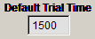
The Default Trial Time should be set to the Military Time of the majority of your cases. If you have more than one trial time, you can always overwrite the trial time when the ticket is written. If no Default Trial Time is put in, the time will default to 0000 on the tickets, but can be overwritten as well.

The option to Create CMS Files will automatically create data files for every Ticket and Warrant Service done in LawTrak. These files are kept on the server until a message is sent from the CMS program requesting the information. If your court is not on CMS, do not use this function.

By law, every court should charge a 3% STP fee. This should always be checked on. Whether or not your court chooses to impose the fee is up to your Judge.
If your court imposes a Credit Card Fee, you can add that to the Court Fees when you take in a receipt if you fill out exactly how much you charge for the fee. You can either charge a Percentage of the Fine (usually 3 or 4%), or a Flat Fee. To automatically calculate the fee, you must fill in one option or the other. You cannot have both options.
The option to Use Master ID Addresses on Mailings will cause printouts like NRVC’s to use the Master ID address instead of the address on the actual ticket. Theoretically, the Master ID has the newest address for an individual. However, this option assumes that the Master ID is incredibly well-kept. Most of the time, using the address on the Ticket or Warrant gets a better result.

Most of the time, the option to automatically apply receipts to restitution first should be checked. If it is not selected, you will have to apply money to either restitution or fines before you run monthly assessments. Selecting this option keeps the money collection consistent.

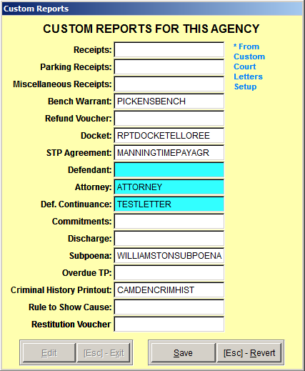
Edit User Defined Reports

If your court wants to have reports that are different from the Default LawTrak reports (i.e. different Docket or Bench Warrant Layout), LawTrak Support can make the reports on this screen look any way you wish. We will create the report and tell you what the name is so you can fill it in on this screen. This will cause LawTrak to use a custom report instead of the default.

The three reports with Blue Backgrounds are created in the Custom Court Letters, and serve as a short-cut on the Courtroom Proceedings screen to print the letters quickly.

Incident Report Settings

Top Section: Incidents
Side Button: Settings

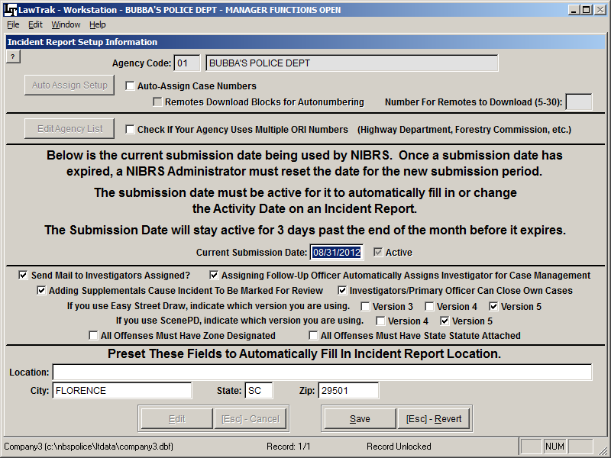

This screen contains information about how your agency deals with Incident Reports.

If you want to automatically pull in the Current Submission Date when officers validate an incident, you must fill this in. If it is left blank, or if the date expires, the officers will be asked for the Activity Date when they validate an Incident Report.

If your agency wants to allow LawTrak to automatically assign case numbers, you can turn on the option to Auto-Assign Case Numbers and run the setup.

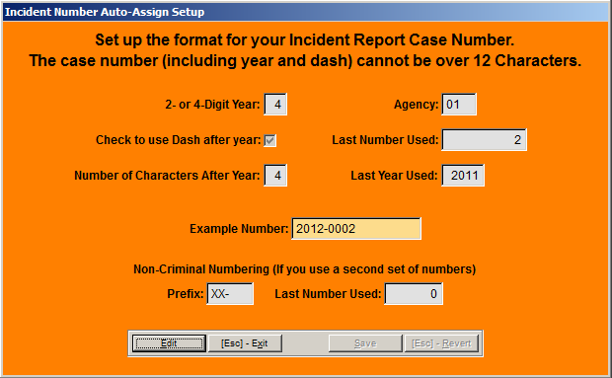
The only format LawTrak will use for auto-assigning is the year (can be 2 or 4 digits), a dash (optional), and a sequential number. The number you set up cannot be larger than 12 characters due to SLED restrictions. This number will automatically reset itself to 0 at the beginning of the next year.

There is also a setup to allow remotes to download blocks of numbers, and the number of cases they should download. This allows the remotes to use the automatic numbering system instead of relying on a dispatcher to give you a number.
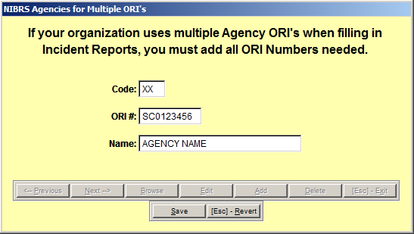
If your agency uses Multiple ORI Numbers, you will need to set up the Agency List to use with your Incident Reports. This option should only be selected by state agencies (Highway Department, Forestry Commission, etc.) where the agency crosses more than one county line, and the incident reports need to be numbered according to the county where they occurred. Set up the ORI’s and County Names your agency uses. If you are in doubt as to whether your agency uses Multiple ORI’s, please check with SLED.

If you fill in the Field Presets, they will automatically fill in when the officer starts the Incident Report. These fields can be overwritten in the Incident Report if necessary.

There are several “switches” that can be turned on, and are explained as follows:

Send Mail to Investigators Assigned: When an investigator is assigned in Case Management, LawTrak will send a mail message to that investigator if the Officer ID is linked to the User Name.

Assigning Follow-Up Officer Automatically Assigns Investigator for Case Management: This option is used mostly in smaller agencies. When an officers puts in the Follow-Up Officer in the Incident Report, it will automatically assign that follow-up officer as the Investigator without any input from the person responsible for assigning investigators in Case Management. If your follow-up officer is always the investigator, feel free to turn this on.

Adding Supplementals Cause Incident To Be Marked For Review: By default, adding a supplemental report does not cause an Incident Report to go back for review. This triggers a review when a supplemental is added.

Investigators / Primary Officer Can Close Own Cases: This option is used mostly in smaller agencies. This allows the Investigator and/or Primary Officer to close their own cases in Case Management even if they are not designated as a Case Manager.

All Offenses Must Have Zone Designated: If your agency wants to require Zones on all Incident Reports for reporting purposes, you can turn this switch on. The Zone must be entered for the offenses before they can validate an Incident Report.

All Offenses Must Have State Statute Attached: If your agency wants to require State Statutes to be entered for Offenses on an incident report, you can turn this switch on. The State Statute must be entered for the offenses before they can validate an Incident Report.

If you are using Easy Street Draw or ScenePD, there are switches to tell LawTrak which version you’re using.

