ADDITIONAL SETUPS
Warning / Alert Setup

Top Section: Administrative
Side Button: Data Entry

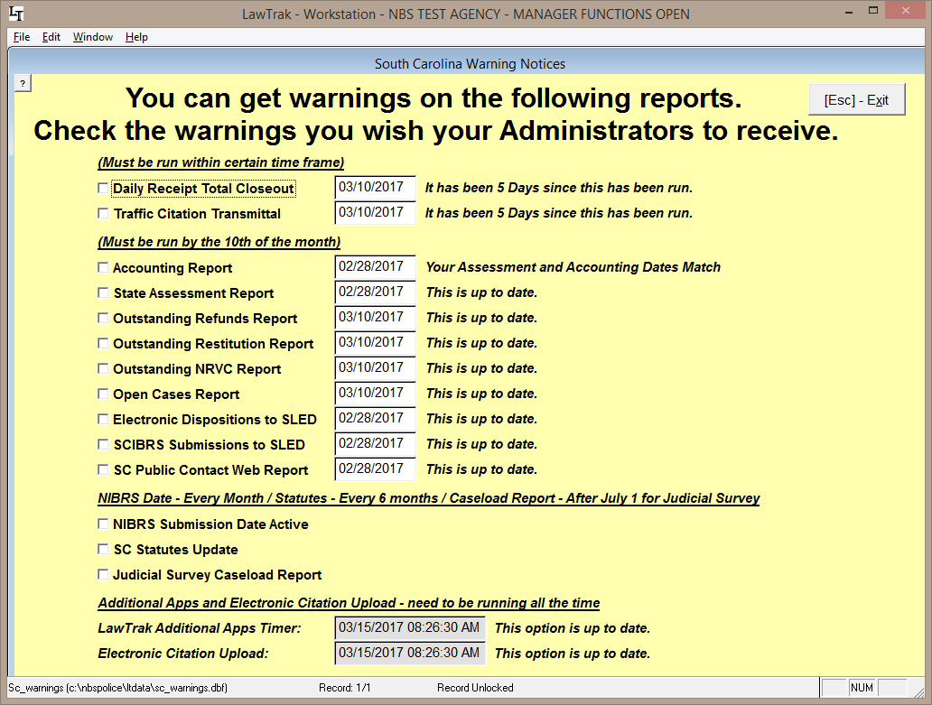

This option tells LawTrak which warnings to check to notify Administrators when they log in if something is not correct.

If the option is checked, the program will warn you if things are overdue. In this example, the Daily Receipts Total Closeout and Traffic Citation Transmittal have been checked. When an Administrator logs into LawTrak, they should receive a message similar to the one below.

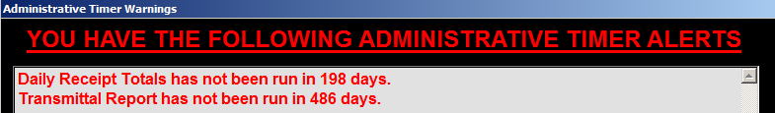

If you do not want warnings to appear, uncheck the options. If there is a warning that is vital to the program running correctly (i.e. Reindexing, Upgrading, etc.), the LawTrak will warn you whether alerts are checked or not.
User Information – Names and Passwords

Top Section: Administrative
Side Button: Lookups

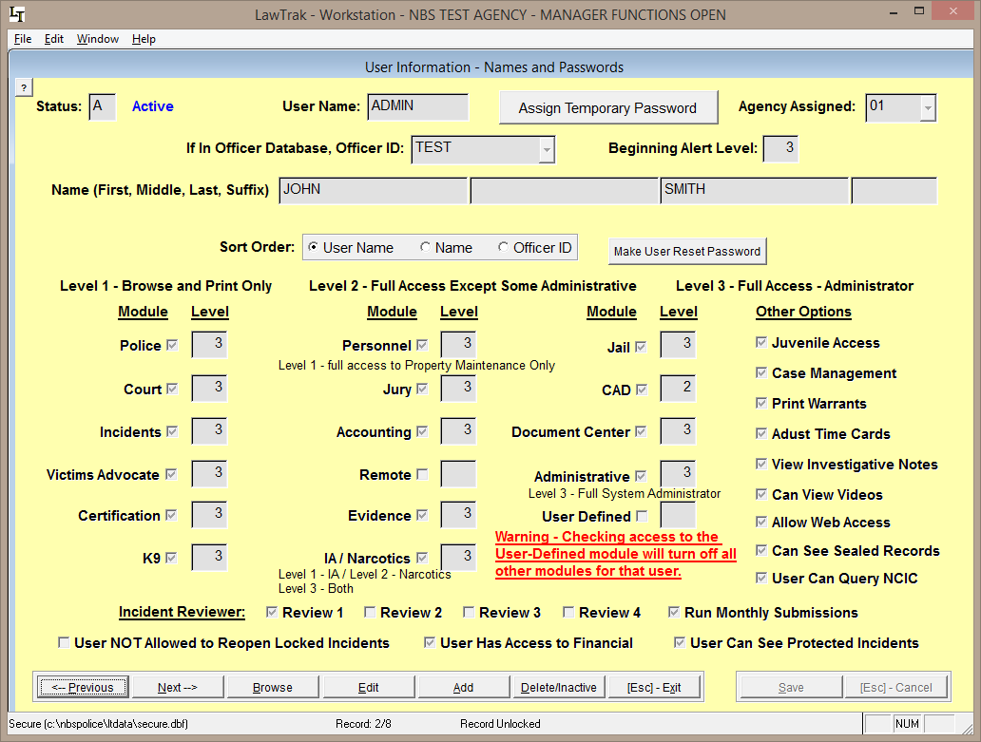

This file contains information about User Names and Passwords allowed into LawTrak, and what level of access the user will have. Every person accessing LawTrak should have their own User Name and Password. This will allow the program to track what users are doing. Only someone with Administrative Level 3 can access this screen.

Every entry must have a unique User Name. This can be up to 10 characters/numbers. Every user name must have a Password.

Delete/Inactivate Users: When a user is no longer allowed into LawTrak, he should be deleted off this screen. If a user is temporarily barred from the system (i.e. password not reset before time limit expires), he can be temporarily inactivated. Pressing the Delete/Inactive button once will Inactivate the user. Pressing it again will mark the user for Deletion. Pressing it a third time will bring the user back active.

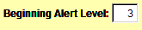
The Beginning Alert Level will determine which alerts/warnings the user can see when he first logs onto LawTrak. An Alert Level of 3 will show most warnings.
Setting Access to Modules and Levels
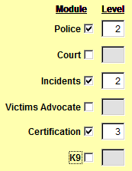
A user can be assigned to specific modules within LawTrak, and kept out of other modules. Each module has a Level associated with it. The Levels basically correspond as follows:
Level 1 – can Browse some records and print some reports. No data entry is allowed.
Level 2 – can Add, Edit and mark some records for Deletion. This is the basic level set for most individuals using the program.
Level 3 – can access any part of the module and run most administrative functions for the areas they are allowed in. Can delete most things.

As seen above, you can mix the levels to different parts of LawTrak. For example, if this user is allowed to enter tickets and incidents as a normal user, but is in charge of keeping track of Certification, he can have Level 2 in most areas and Level 3 in Certification.

There are a couple of modules that do not follow this basic rule:
Personnel – Level 1 has full access to the Property Maintenance, but cannot see the Complaints and Disciplinary Actions.
Evidence – Level 1 can put in the initial evidence entry (i.e. collecting it in the field), but cannot edit or move the evidence once it has been entered.

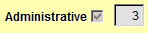
WARNING: Allowing someone access to the Administrative module may give that user more influence in the program than you want. A Level 3 Administrator can change his own level in any module, and can add or change the access of other users. This should be given to as few users as possible. Administrative Level 2 has the ability to do some maintenance (i.e. Reindex files), but cannot reset access levels for anyone.

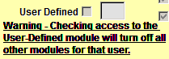
There is an option to set a user as User Defined. This will allow you to assign up to 13 very specific buttons to that user. Example: A user is responsible only for writing Parking Tickets. He can be assigned the Parking Ticket menu button, and some of the Report buttons. He will not be able to get into any other parts of the program.
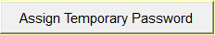
Once you get the user entered, you must Assign a Temporary Password. When the individual logs in for the first time, he must change his password to something more permanent.

All passwords have a 90-day expiration, and you must use 10 passwords before you can re-use any old ones. You can change the user password as often as you want.
Attaching Users to Officer Database

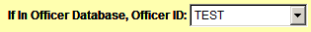
If the user is also in the Officer Database, you can attach the Officer ID to the user. This will allow parts of the program to access the Logon Name as well as the Officer ID number if needed. For example, there are certain places in LawTrak that will send LawTrak Mail to officers, but must have the Logon Name attached since the LawTrak Mail works on the User Name.

The NIBRS Reviewer options should be assigned to those users Reviewing Incident Reports, and those doing the NIBRS submissions.

Other Options

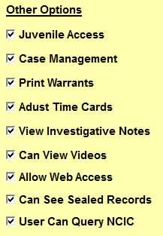
These options allow for some specific access to parts of the program, or keeps the user from accessing some sections.

User NOT Allowed to Reopen Locked Incidents – This option is normally turned off, and users are generally allowed to unlock reports to make necessary edits. An Incident Report is locked when it is either Reviewed or Submitted. Turning this option on for a user will keep him from editing a report once it has been reviewed.

User Has Access to Financial – This will allow the user to enter receipts and run money collection reports.

User Can See Protected Incidents – Normally if an Incident Report is Protected, only the user who protected it can see any information. If a user is responsible for reviewing Incident Reports, he may need to see the protected report.

Juvenile Access – A user can override the Juvenile settings on printing reports.

Case Management – Allows a user to assign investigators and close cases in-house.

Print Warrants – If this option is checked, the user will be allowed to Add, Edit and Print Warrants.

Adjust Time Cards – The user can make corrections to Time Cards.

View Investigative Notes – Investigative Notes access should only be given to Investigators or those reviewing the cases. These notes normally do not print out with the regular Incident Reports. Only someone with this option checked will be allowed to view, create, or print incident reports.

Can View Videos – This will allow the user to view videos attached to Incident Reports.

Allow Web Access – There are a couple of places in LawTrak where the user can have an Internet Page displayed. Normally this is not used.

Can See Sealed Records – This option allows the user to see the Sealed Records which contain expunged Incidents and Court Cases.

User Can Query NCIC – This allows the user to do LawTrak Quick Queries that can tie into several NCIC systems that we work with.
Officer Setup

Top Section: Administrative
Side Button: Lookups

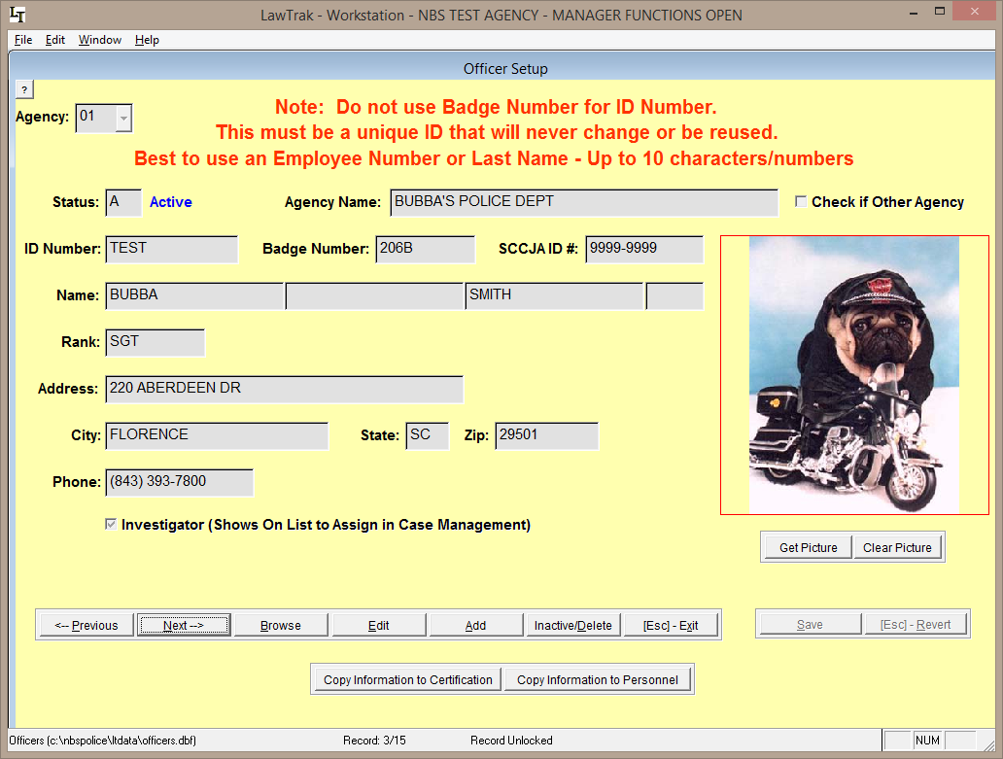

This screen will allow you to set up Officer Information. Each officer is assigned to a specific agency.

For the ID Number, we recommend you use a code that will not change (i.e. Name, State ID, Employee ID, etc.). Since Badge Numbers tend to be reused within an agency, it is recommended that the badge numbers not be used as the ID numbers.

Inactive/Delete: Pressing this key once will Inactivate an officer. Pressing the key a second time will mark the record for Deletion. Pressing it again will bring the officer back active.

If an officer code has records attached to it (e.g. Tickets, Incident Reports, etc.), you should leave the Officer ID in the database but mark it Inactive if the officer is no longer with your agency. Deleting the officer can create problems in running reports later. If you need to change the Officer ID so you can re-use the ID Number, see the Change/Merge Officer ID Numbers Help File.

If the officer is assigned cases as an Investigator, put a check mark in the box beside Investigator. The officer will then show up on the list of officers who can be assigned case in Case Management.

Once the Officer ID has been saved, you can utilize the buttons at the bottom to copy the officer information to the Certification and Personnel modules. This will start an entry into these modules with the Officer’s ID Number and Name. There is a lot of additional information needed for these other modules once the initial record has been created.

SC State Statutes

Top Section: Court – Administrative
Side Button: Lookups – Data Entry

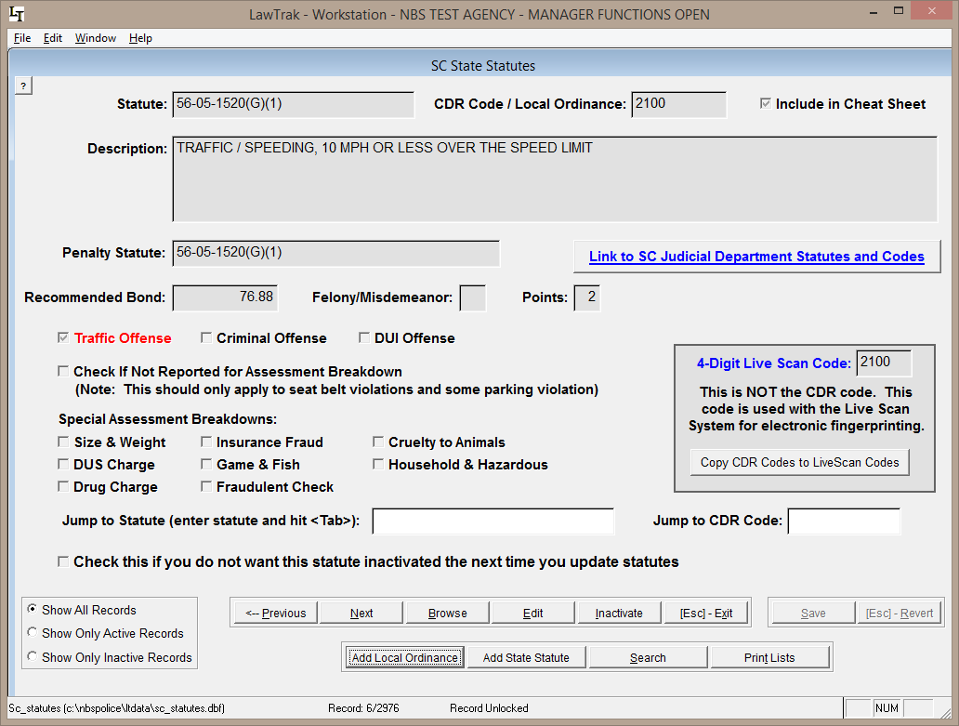

The SC State Statutes section contains records for all State Statutes that LawTrak uses, as well as any Local Ordinances you may want to put into LawTrak. Any time you fill in a ticket or warrant, it must be associated with one of the statutes in this file.

The Statutes are updated by a file from the State Court Administration, and contains all active statutes at the time the file was downloaded. Updates are done every 2 or 3 months, or when there are several statutes added or updated.

The South Carolina Statutes are in a format XX-XX-XXXX so they can be kept in numerical order. Local Ordinances are always given the state statute number 00-00-0000 and the local ordinance number is put into the CDR Code / Local Ordinance field.

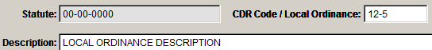
To add a local ordinance, press “Add Local Ordinance,” fill in the Ordinance Number and a Description. This will put the ordinance into the available statutes that can be used when filling out tickets and warrants.
It is possible to enter additional State Statutes. Please call LawTrak Technical Support to find out the rules on adding State Statutes.

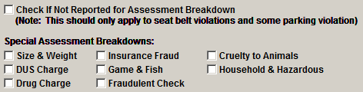
There is a section of Special Assessment Breakdowns for specific statutes. For the most part, LawTrak will know what to do with the individual statutes. The only time this needs to be adjusted is if you add a State Statute that is not in the normal file.

There is an option on the individual statute to “Include in Cheat Sheet.” This option will break the statute out into a “most commonly used” list that can be printed easily.

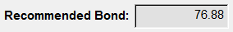
The Recommended Bond field can be filled in to automatically feed the Fine/Bond amount into tickets created when a specific statute is used. LawTrak does not calculate this amount when the statutes or fines are updated.

You can Inactivate a statute or local ordinance by pressing the Inactivate button. Statutes are not deleted from this screen unless it’s done by the upgrade function and the statute has never been used. Inactivating a statute keeps it from being used again, and takes it off of the statute list when searching from Tickets and Warrants. An Administrator can Reactivate an Inactive Statute.

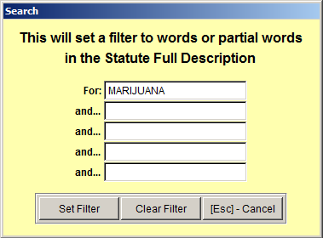
Searching for Statutes – Selecting the Search option will bring up a screen where you can fill in Search parameters. These parameters will look in the Full Description of the Statutes, and pull up any statutes matching the words or partial words being searched.

There is a hot-key short-cut that does the same sort of Search function on Statutes. Pressing F6 will bring up a similar screen from anywhere in the program. (See Statutes Help Screen Help File for more information)
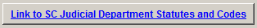
There is a Web Link to the SC Judicial Department Statutes and Codes page. If there is any question about a specific statute, this is the place to look it up.

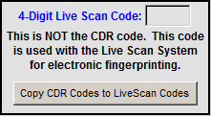
The section containing 4-Digit codes is only for use with a Jail’s Live Scan process. LawTrak works with some Live Scan systems and exports records from Booking Reports. If you tie a Live Scan code to a State Statute, this code is included in the export.

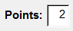
If there are license points associated with the statute and they are not already filled in, you can enter them. These will automatically pull into the Uniform Traffic Ticket and upload to DMV if necessary. Please note that you can also enter the points directly into the Traffic Citation if needed.

Traffic Offense Code Setup

Top Section: Court
Side Button: Lookups

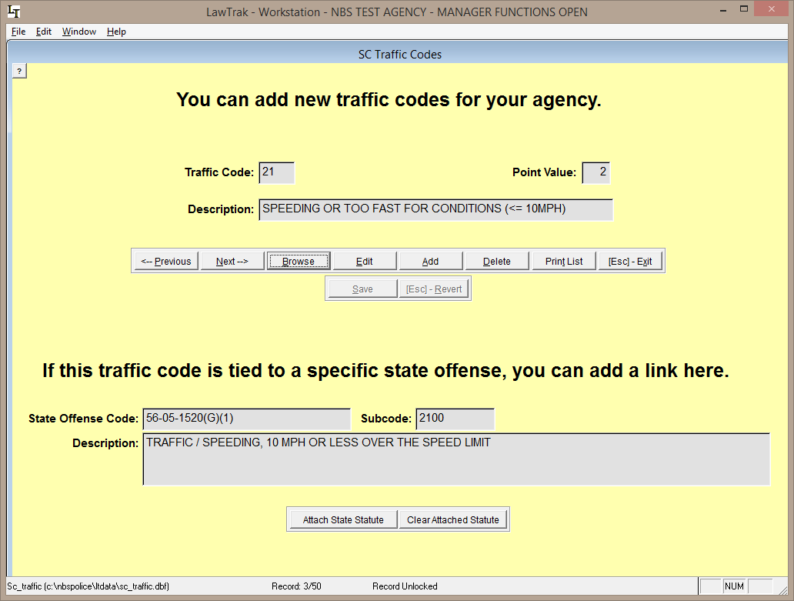

This file contains the list of Traffic Codes used on Uniform Traffic Tickets. You can add new codes to this list if your agency uses additional codes. You can also attach State Statutes to the codes to make filling in Tickets a little easier. Since the Uniform Traffic Tickets do not use the Traffic Codes any more, these are completely optional. They can be used as shortcuts for any type of offense – traffic, criminal, local ordinance – that you want to make a shortcut for.
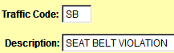
If you want to add an additional code, press the Add button, make up a 2-character traffic code, and fill in the description.

You can attach a State Statute to a Traffic Code. Doing this will cause the State Statute to automatically be filled in as you do a Traffic Ticket. You can also use this option to change the statute attached to any of the traffic codes.

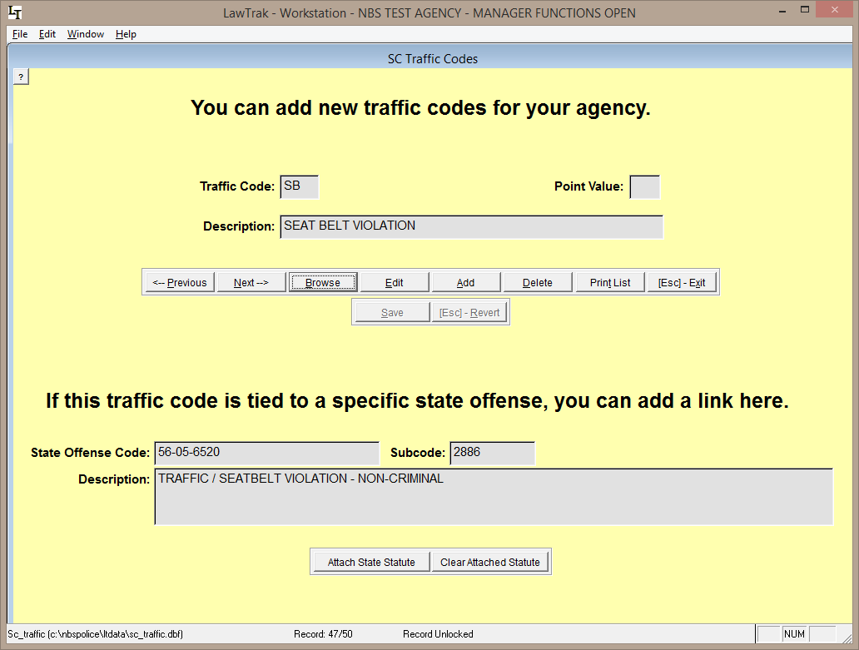

Pressing the Attach State Statute button will take you to a Find Statute screen. Search for the Statute or CDR Code and press the Select Statute button. (See Find Statute Help File for more information)

NIBRS Inhouse Code Setup

Top Section: Administrative
Side Button: Lookups

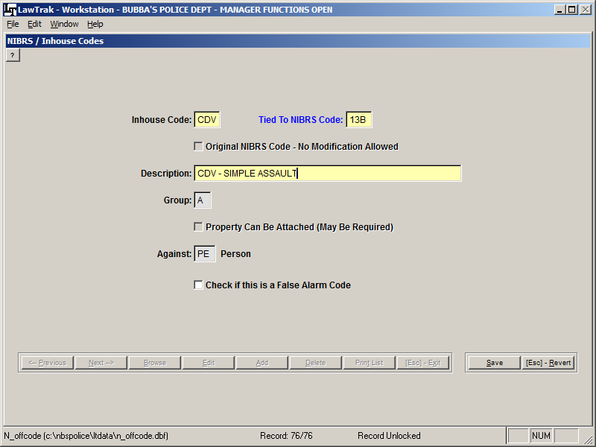

This screen allows you to add inhouse codes used in Incident Reports. These codes can be used to track specific types of offenses that may fall under a larger group.

In the example above, we make up a specific code for CDV, which normally falls under a 13B – Simple Assault code. If you use the CDV code in the incident report offenses, you can start tracking this code and get statistics very easily. If you do not use a specialized code and want to count CDV’s, you would have to print out all 13B codes and manually count the CDV codes within the 13B.

You can also make up codes for things that are normally not reported to SLED (i.e. DUS, Alarm Call, Warrant Service, Assisting Other Agency, etc.). Doing a simple incident report using these new codes will give you the ability to get quick counts to show how many your agency has done for a time period.

Disposition Setup

Top Section: Court
Side Button: Lookups

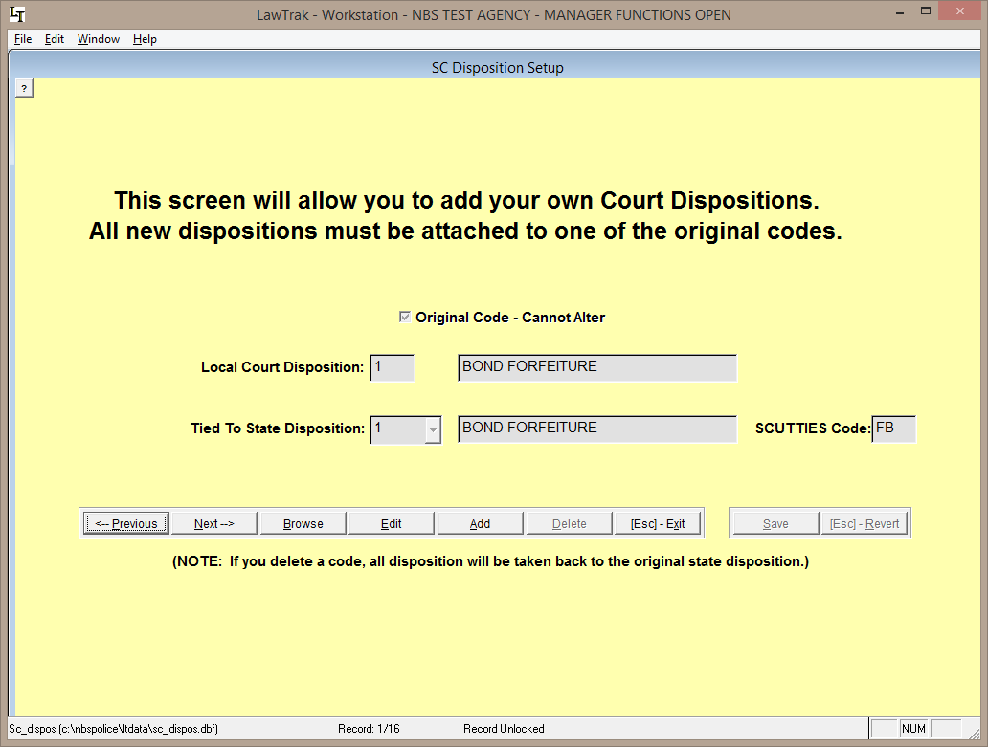

This file contains the list of the South Carolina Court Administration’s Disposition Codes. The main codes 1-9 cannot be edited or deleted.

New Disposition Codes can be added as long as you can tie them back to one of the original codes so that the Caseload/Disposition Report associated with the Judicial Survey can be run at the end of the fiscal year.
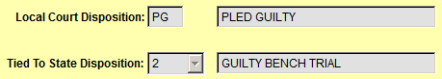
The new dispositions can have a code of 1 or 2 numbers/letters, and the description for the code can be whatever you wish. Tie the code back to one of the original state codes and press Save. You can make up as many disposition codes as you want.

Custom Letter Setup

Top Section: Court – Parking – V.A.
Side Button: Lookups / Settings

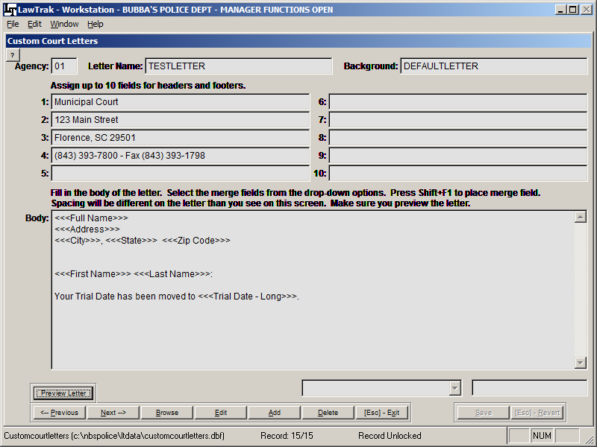

The Custom Letters can be found in many sections of the program. They allow the user to set up mail-merge documents for various types of letters to send out to defendants, attorneys, jurors, victims, etc. Each module has the mail-merge fields unique for that module, but all letters are created basically the same way.

Adding a New Letter

When you add a new letter, you will need to create a Letter Name. There should not be any spaces in the letter name. Some Custom Letters will also allow you to select a background. If you have a specialized background that was made up specifically for your agency, you can replace the Background name with that specialized background name. If you are unsure whether or not you have a customized background, please call LawTrak Support.

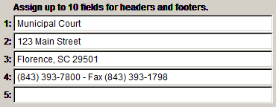
Depending on the background, you may have to fill in certain header / footer fields. The DEFAULTLETTER background can have up to six (6) lines for a letter head, and it automatically includes today’s date. You don’t need to fill in every header or footer line, and if you have a special background, these header/footer fields may correspond to something entirely different.
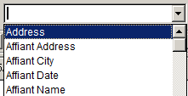
There is usually a drop-down box of some kind near the bottom of the screen. This drop-down contains all of the fields that can be merged into the letter. Depending on which module you are in, your choices will be different.

Depending on which mail-merge letter setup you are in, there will be instructions on how to get the drop-down field into the mail-merge letter. In this case, place the cursor where you want in the letter and press Shift+F1. Some other screens instruct you to press <Ctrl>+V.
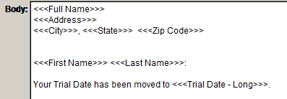
The merged field will be surrounded by <<< >>> signs. The fields can be placed anywhere in the body of the letter you wish.

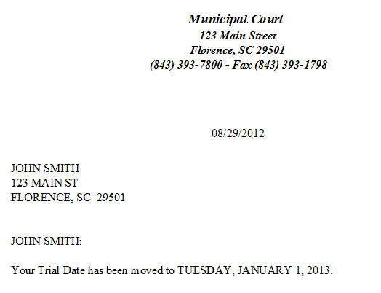
Once you have the letter formatted the way you want, press Save. In most cases, you will be able to Preview the letter to make sure it looks the way you want it to look. If you want to change the layout, edit the letter until it looks correct.

Uniform Traffic Ticket Inventory

Top Section: Police – Admin
Side Button: Settings

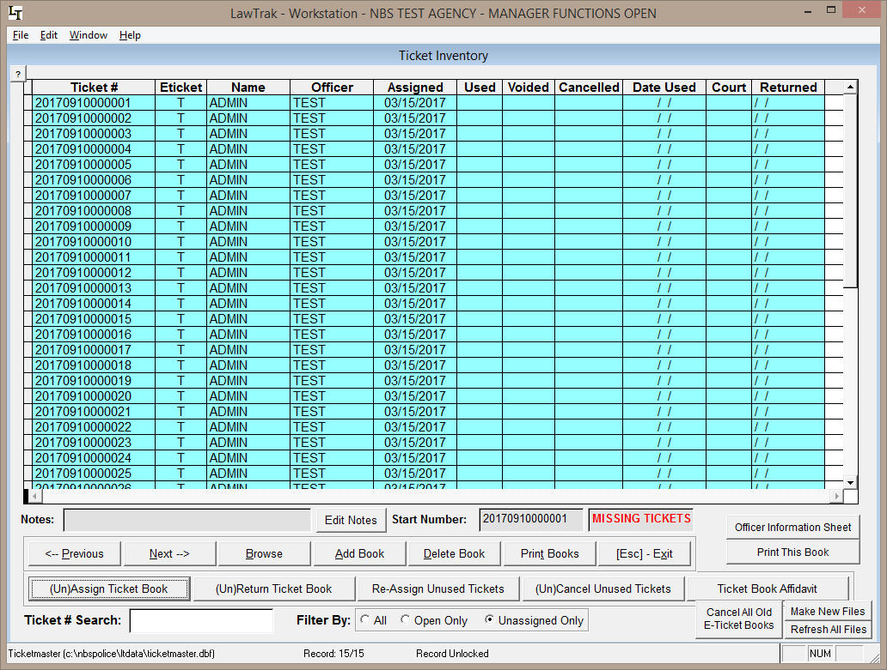

The Uniform Traffic Ticket Inventory screen is used to track tickets that have been assigned to officers. It is also used to give E-Ticket numbers to officers in the field.

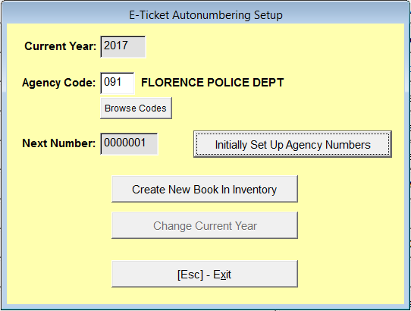
If you want to issue out a new E-Ticket block for a remote user, you must go to the E-Ticket Book Creation screen. This keeps track of the blocks that have been created in the Inventory, and is used to change the year on the blocks at the beginning of the new year. Simply create a new book in the inventory, and it will be ready to assign. You can create as many books as you need. Once created, assign the books out in the Ticket Inventory screen.

If you are assigning Warning Tickets, City Arrest Tickets, or Parking Ticket blocks, the process is a little different, but basically the same. Create the books and assign them out.

The grid tells you the ticket number, who it is assigned to, whether it has been used, and the ticket status in court. If the item on the grid is blue, that means the ticket has not been entered into the system yet.

